Data Modification 2(using MySQL server)

INSERT INTO Location(LocNo, FacNo, LocName)

VALUES ('L107','F104','Door');

Before Modification:

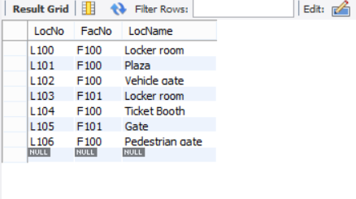

Resulting Table Screenshot:

